**The Daggers:**

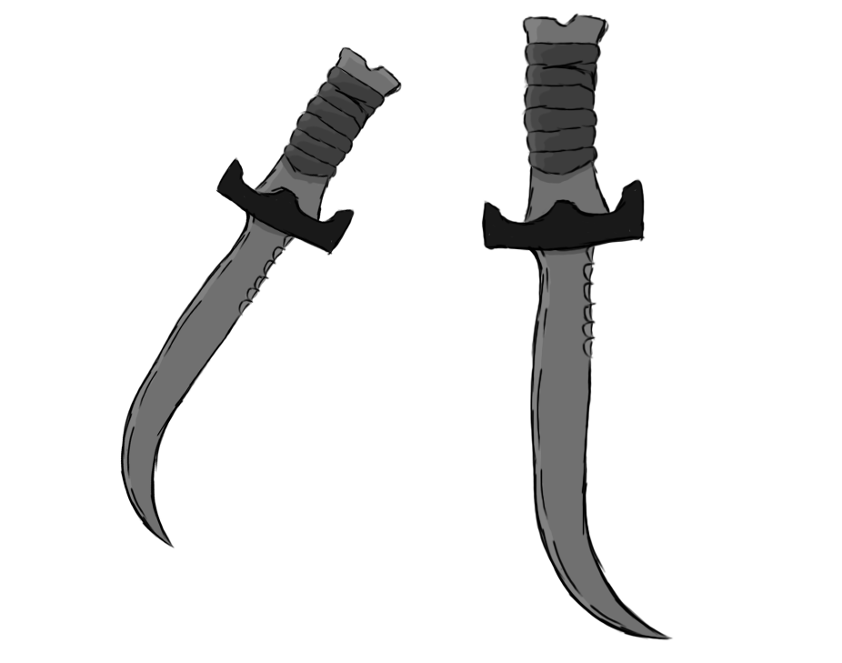

Figure 1 - Weapon: Daggers

**Brief Synopsis**

The daggers are dual-wielded weapons with exceptionally high damage output. Their primary use is to take out a single, high-health enemy, as while they can do lots of damage, their range is the smallest of all weapons in the game. This requires the player to be extremely close to the enemies they are fighting in order to use the daggers effectively. This allows players aiming for faster speeds a quicker way of disposing of enemies, while also increasing the risk of the player taking damage due to their proximity to the things they are fighting.

**Special Ability**

**Wall Running:  
 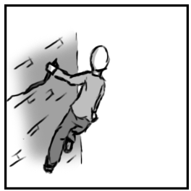**

Figure 2 - Animation Storyboard: Wall Running

**Special:** The player jumps and locks their movement onto the wall. Running forward keeps them attached, allowing them to travel horizontally, giving them access to potential skips and shortcuts.

**Combat Abilities**

**Hack ‘n’ Slash:**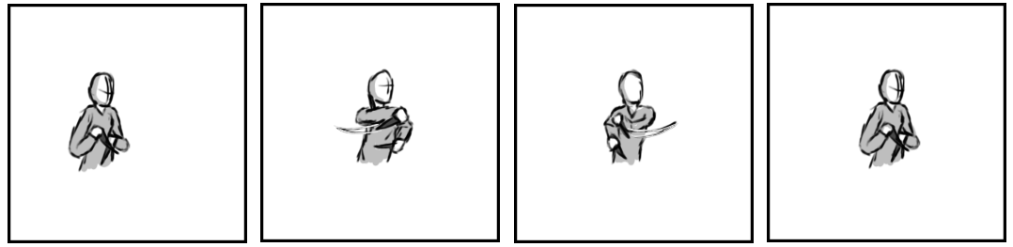

Figure 3 - Animation Storyboard: Hack ‘n’ Slash

**While grounded and stationary:** The player brings their daggers across and away from their chest. If this attack is repeated it will enter into a combo where the daggers will land continuous strikes, finally ending by returning to their resting position.

**Lunge:**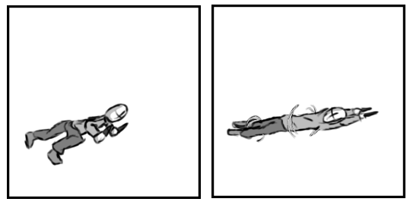

Figure 4 - Animation Storyboard: Lunge

**While grounded and in motion**: The player propels themselves forward while spinning. During this the player will have brief invulnerability to attacks, while dealing damage to anything they meet as they travel.

**Killer Top:**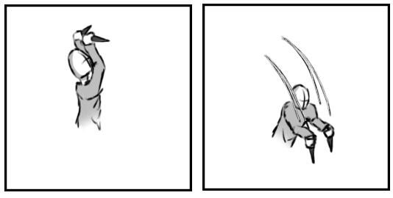

Figure 5 - Animation Storyboard: Killer Top

**While aerial:** The player raises both daggers into the air and comes crashing down with them drawn. Any enemy directly underneath the player will take a massive amount of damage.